MID TERM TEST REPORT
PENGENALAN PERANCANGAN WEB
S-1-INFORMATION SYSTEM

“ HTML and CSS Implementation on Static Web”



Arranged By:
Name | Nugroho Ari Anggoro
SIN / NIM | 21.62.0181
Lecturer | Irma Rofni Wulandari, S.Pd., M.Eng
Assistant Coordinator
Exam Date | Start : 17 may 2022 - end

S-1 – INFORMATION SYSTEM
COMPUTER SCIENCE FACULTY
AMIKOM YOGYAKARTA UNIVERSITY
2022

MID TERM TEST

Web Gelar Karya Mahasiswa

Tools
(Fill in the tools and software you use)
- Visual studio code.
- Google chrome.

Result and Analysis
(Fill in with the results and analysis of the web page creation, including the script screenshots and output results, then explain it. Describe the development and characteristics of the GKM website that you created. Point out which parts of the display you developed along with the coding. Use scientific language/standard Indonesian language, not slang. Make it as complete as possible, and do not try to copy-paste. Be careful with copying and pasting. Each student has to explain the results and analysis uniquely)
Index.html script screenshot
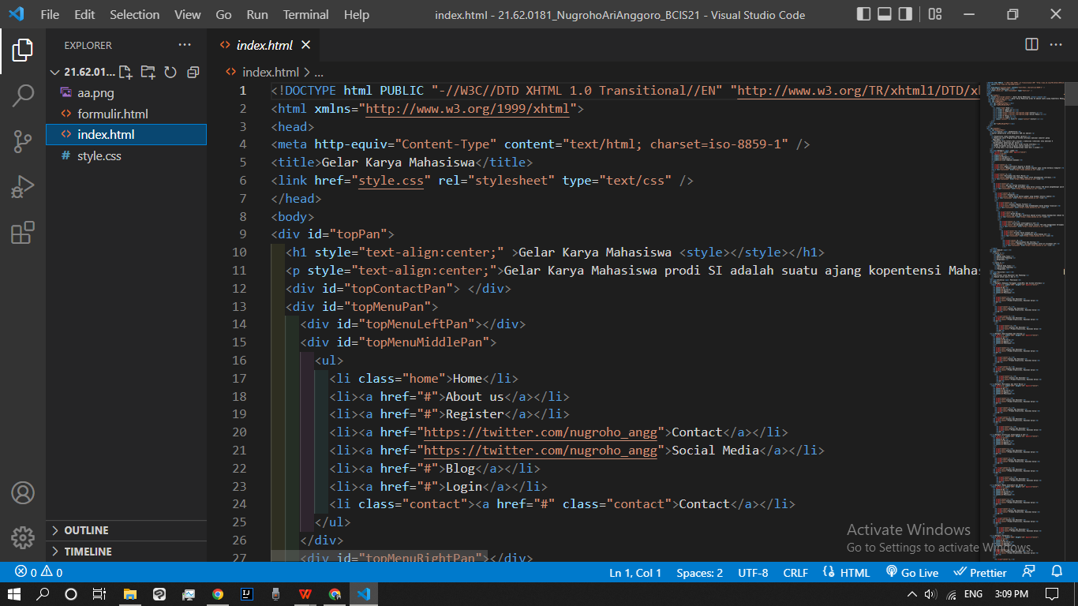
Index.html output display
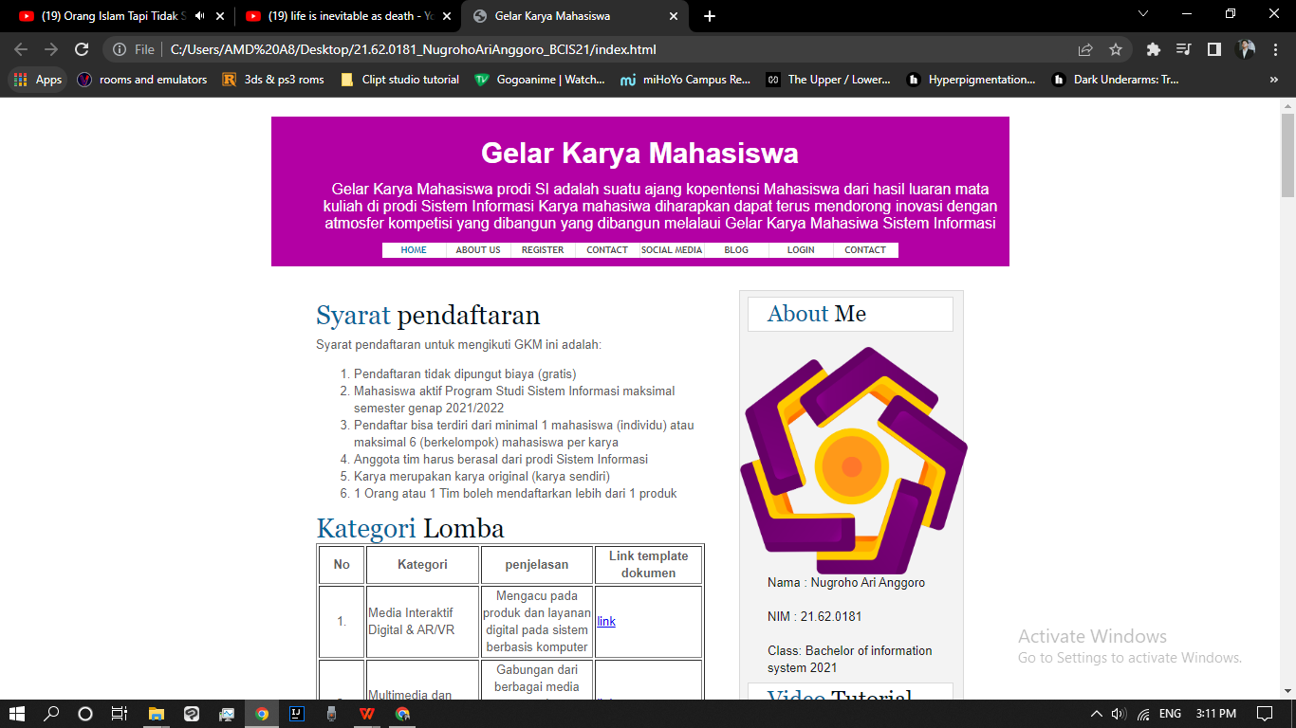
Formulir.html script screenshot
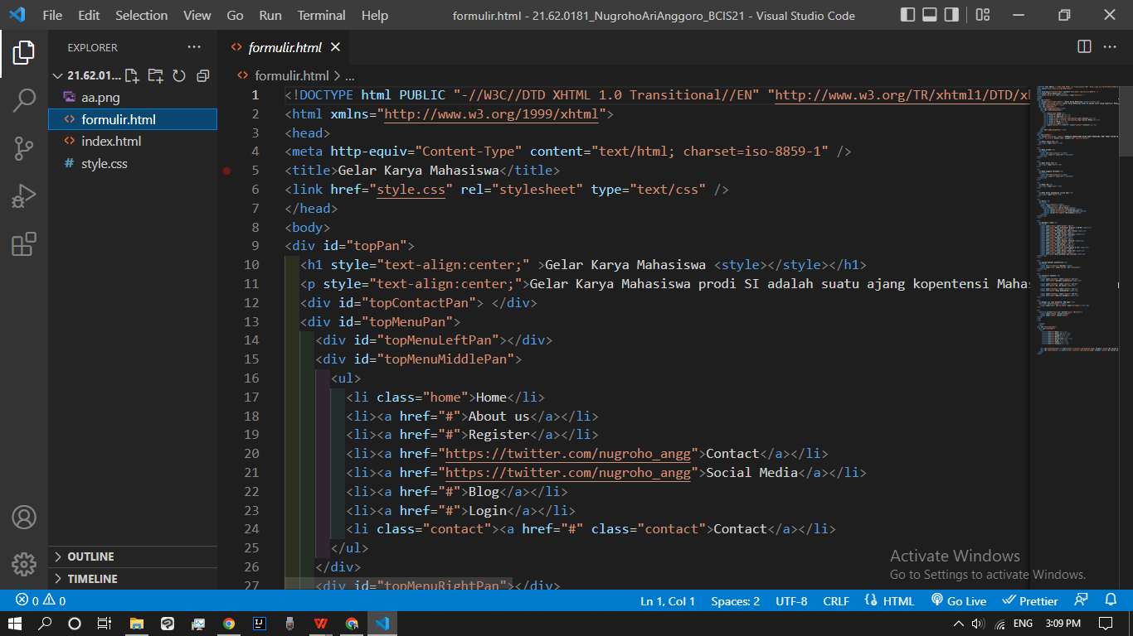
Formulir.html output display
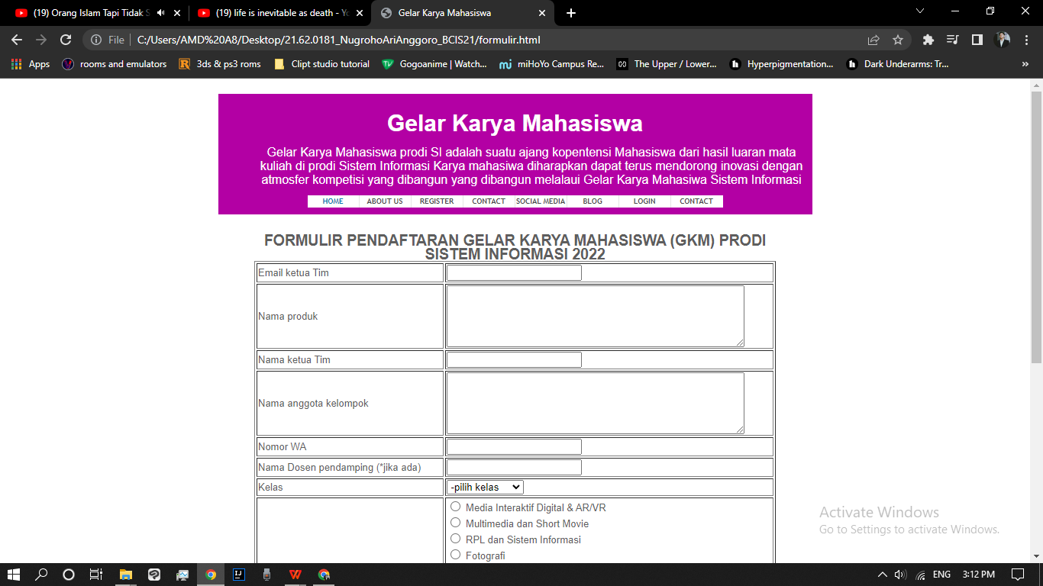
Style.css script screenshot
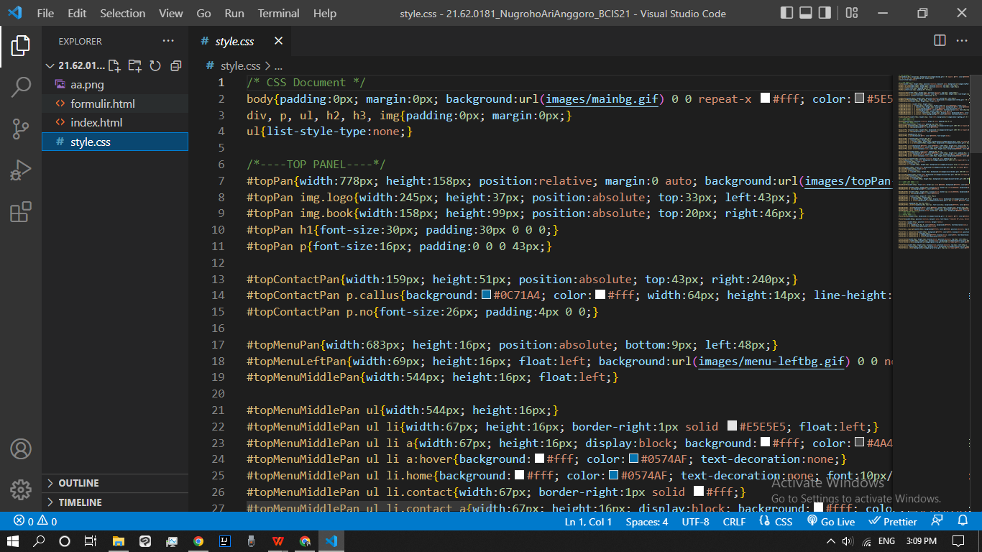
Description:
I used visual studio code to wrote html and css
And I used google chrome to display it
I used google to search the things

References
(Fill in the references that you use while working on the assignments)
- Youtube.com.
- Google.com

